

Document For
Self Service Request Page

`
Document Revision History

Date | Version No. | Author | Reviewer | Approver | Change Summary
07-07-2025 | 1.0 | Narendar V | Navu | **62

Contents
1 INTRODUCTION 4
2 FUNCTIONAL REQUIREMENTS………………………………………………………………………………….

INTRODUCTION
This document outlines the requirements and proposed approach for developing a custom Self-Service Request Page using Oracle APEX, which will be integrated with the Oracle E-Business Suite (EBS) and EBS Workflow Engine. The goal is to provide end users with a simplified, user-friendly interface for submitting various requests, while ensuring these requests follow the standard EBS approval and tracking mechanisms.
The solution will be fully custom-built within Oracle APEX to allow for flexible UI design, rapid development, and seamless integration with existing EBS components.

FUNCTIONAL REQUIREMENTS
The proposed Self-Service Request Page will consist of three main pages, each serving a distinct purpose within the overall flow. The application will be developed using the Oracle APEX and will support role-based access and dynamic form rendering based on request type.
Page 1: Request Type Definition
This page will allow administrators to define various Request Types and their associated fields. Each request type can have a different set of input fields, which will be configured and stored for dynamic rendering during request creation. This enables flexibility to support multiple request scenarios, such as Leave Request, Loan Request etc.
Page 2: Request Overview (Role-Based View)
This is the main request overview page and will be role-based:
- User Role: Display the requests which are raised by the logged-in user.
- Manager Role: Display the requests which are pending for approval.
- Admin Role: Displays all requests submitted by any user.
This page will also include a “Create Request” button. When clicked, it will open a pop-up window to initiate a new request (Page 3).
Page 3: Dynamic Request Creation
This page will serve as a dynamic request form. It will render different sets of input fields based on the selected Request Type. The form structure (i.e., field names and types) will be determined at runtime based on the configuration defined in Page 1
For Example:
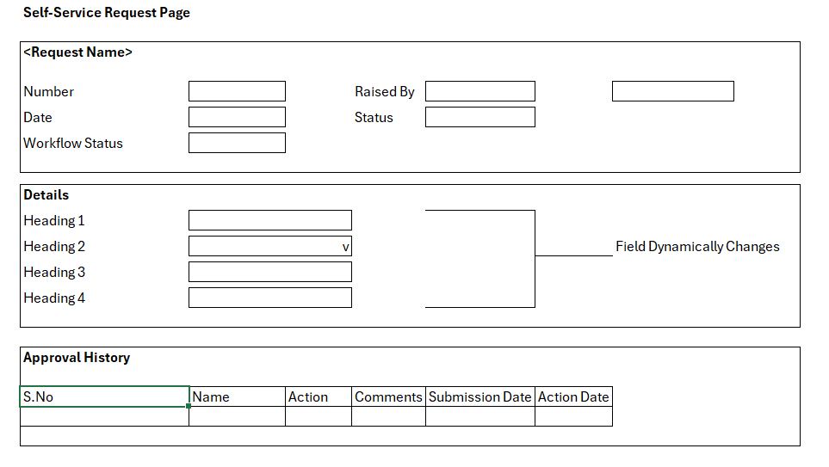
The page will remain in a single form but will dynamically adjust its input fields according to the selected request type.

